

[www.thenorthernavgroup.co.uk](http://www.thenorthernavgroup.co.uk)

**Riding Mill Parish Hall, Millfield Road, Riding Mill, Northumberland NE44 6DJ**

**Next meeting: Saturday 19th October 2024 at 10:00 am.**

# 

**The Digital Magic Lantern Show**

**Presented via Zoom by**

**Linda Gibbs MPAGB AV-AFIAP and**

**Edgar Gibbs FRPS MPAGB AV-AFIAP**

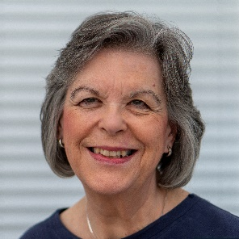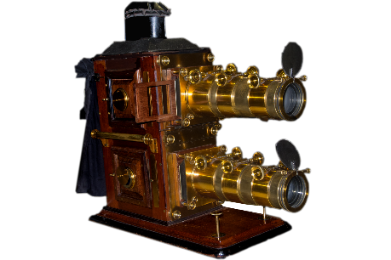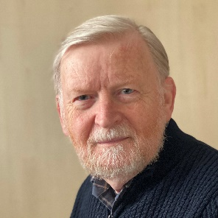

**Linda and Edgar have been producing AVs since the 1980s, and in 2017, they were awarded the Royal Photographic Society's AV Group Dobson Henry Medal for their contribution to the AV medium.**

**During the AV Day, Linda and Edgar will provide constructive and encouraging comments on Members' AVs, show some of their award winning AVs, and demonstrate some AV techniques, including deconstructing one of their AVS, to see how it was made and produced.**

**The cost of entry to this event is £10.00 which includes morning and afternoon tea and coffee and a buffet lunch. This is a substantial reduction on our usual entry fee which we are happy to say that we can afford owing to our healthy bank balance!**

**Please note: the meeting will be taking place at Riding Mill.**

**For a map of the location of the venue click on this link:**

[Riding Mill Village Hall](http://www.streetmap.co.uk/map?x=401788&y=561419&z=0&sv=NE44+6DJ&st=2&pc=NE44+6DJ&mapp=map&searchp=ids)

**Attendees’ Sequences**

There will be the usual opportunity in the programme for attendees to show their own AVs before an appreciative and expert audience. Please note that sound and picture reproduction in the hall is unlikely to be exactly the same as that produced by your own home equipment and we cannot adjust this equipment to suit individual sequences.

For this meeting will you please submit your sequences to Pat Johnston. Please follow these instructions:

Presentations must be in .mp4 format where possible and of medium quality. Send your file to Pat using the following programme – <https://www.wetransfer.com> following the web site instructions using his Email address, [patrickjohnston43@yahoo.com](mailto:patrickjohnston43@yahoo.com). If this is not possible send the .mp4 file on CD/Memory Stick to Pat at 25 Hackwood Park, Hexham, NE46 1AX. The sequences must be with Pat by 7th October.

**Payment Details (to include lunch and refreshments)**

**1. Payment by internet banking. Please use this method if possible.**

I must receive payment and the booking form details at least 7 days before the meeting.

**Bank details :**

Account name: Northern Audio Visual Group

Sort code: 53-50-46 Account number 61664553

On the same day that you make the bank transfer please send an e-mail to me at: [david.niman@gmail.com](mailto:david.niman@gmail.com) providing the details shown on the booking form below or send me a completed booking form as an attachment to the e-mail.

**2. Payment by cheque.**

Send a cheque and a copy of the booking form below by post.

Please make cheques payable to **The Northern Audio Visual Group** and send your completed booking form and cheque to:

**David Niman, 32 Mill Hill Close, Brompton, Northallerton, N.Yorks DL6 2QP**

**Telephone: 01609 774530**

Please enclose an SAE if directions to Riding Mill and/or an acknowledgement are required.

**All bookings must be received at least 7 days before the meeting.**

**If you are submitting a presentation this must be received by 7th October .**

*Booking Form: Please type (preferably) or print legibly.*

**Northern Audio Visual Group Meeting Saturday 19th October 2024.**

I / We will be attending the Northern Audio Visual Day on Saturday 19th October 2024.

**Do you have a sequence to show? Please circle: YES NO**

**If ‘YES’ please give the TITLE**

**And DURATION min sec**

**NB Submission of any work implies that you have obtained licences or permissions to use any copyright material included in the sequence and agree that it can be sent to a named assessor for constructive critique.**

Name(s) of all in group.

Contact address

including post code

Email

Telephone

number

|  |  |
| --- | --- |
| Number in party ­­­_____ @ £10.00 per head | Total: £ |

If this is your first meeting, I would be interested to know how you heard of us.

David Niman

Secretary

You can find further information on our website [www.thenorthernavgroup.co.uk](http://www.thenorthernavgroup.co.uk)